The Cape Primary School

**Use their voice expressively and creatively**

**Play tuned (eg. chime bars, glockenspiels) and untuned (drum, triangle, shakers etc) instruments musically**

**Listen with concentration and understanding**

**Experiment with, create, select and combine sounds using the inter-related dimensions of music (pitch, duration, dynamics, tempo, timbre, texture, structure, notations)**

**Fundamental skills**

**Music in the Early Years**

**EYFS Curriculum….**

**30-50 Months**

Enjoys joining in with dancing and ring games. Sings a few familiar songs. Taps out simple repeated rhythms. Explores and learns how sounds can be changed (EAD- Exploring Media and Materials)

Creates movement in response to music. Sings to self and makes up simple songs. Makes up rhythms (EAD- Being Imaginative)

**40-60 Months**

Begins to build a repertoire of songs and dances. Explores the different sounds of instruments (EAD- Exploring Media and Materials)

**ELG**

Children sing songs, make music and dance, and experiment with ways of changing them (EAD- Exploring Media and Materials)

They represent their own ideas, thoughts and feelings through music (EAD- Being Imaginative)

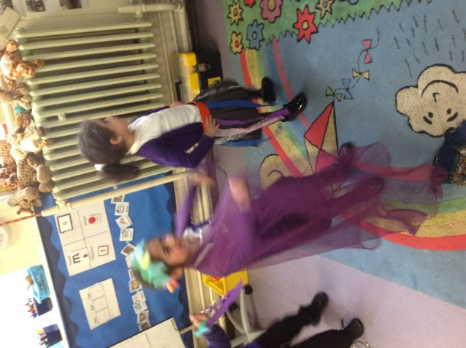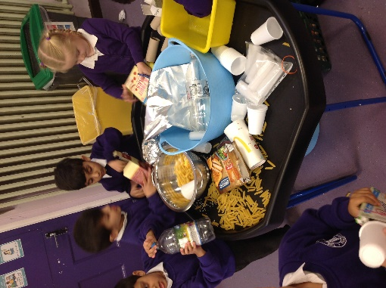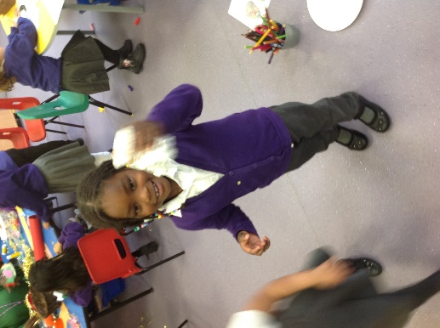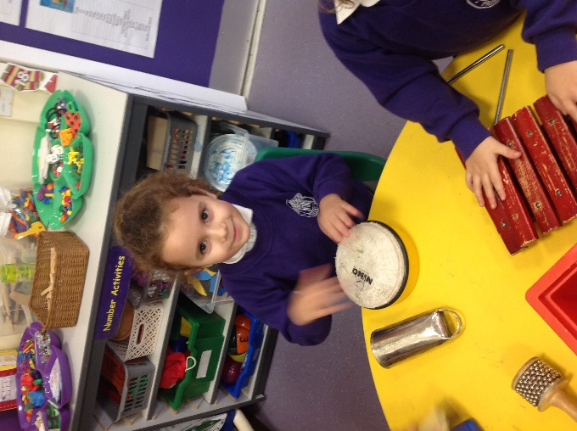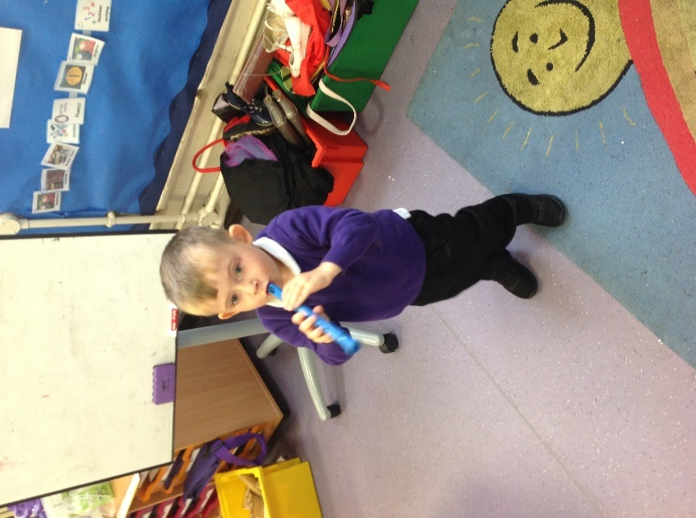

Making up their own dance moves during Dawaii, responding to music

**But Why?….**

Music provides a great tool for encouraging self-expression and as an inclusive uplifting activity that can be accessed by all children, at whatever stage of development, it builds self-esteem. By tuning children into the rhythm of language, through music, it is helping them to hear the patterns of sounds that we know as words and phrases and supports their phonological awareness which will support their reading and writing skills. Music makes children move and can have a direct impact on their physical development. It can support their gross and fine motor control as well as coordination and balance. Music can also support children’s Maths understanding through the use of positional language e.g. high, low.

**Music looks like this….**

Children recall and sing familiar nursery rhymes, songs from the radio and daily routine songs.

Children are using different materials, tools and techniques to create their own musical instruments. Once completed, children explore the sounds their instruments can make, adapting their instruments as they go along.

Children exploring the sounds of different musical instruments.

**“WOW! This is loud!”** using the instruments to explore how the sounds can be changed.

**Progression into Year 1…**

**Use their Voice Expressively and Creatively**

Can use their voice expressively and creatively eg. Can give suggestions for / create different sounds – humming, whispers, whistle, animals, different characters

**Play Tuned (eg. chime bars, glockenspiels) and Untuned (drum, triangle, shakers etc) Instruments Musically**

Can play instruments with control

**Listen with Concentration and Understanding**

-Can say what they do / don’t like

-Can recognise and describe what they can hear eg. instruments, fast/slow, loud/quiet

-Can describe and compare different types of music

-Talk about (appraise) their own and other’s performances

**Experiment with, create, select and combine sounds using the inter-related dimensions of music (pitch, duration, dynamics, tempo, timbre, texture, structure, notations)**

-Explores different sounds – eg. long/short (duration) high/low (pitch), loud/quiet (dynamics), fast/slow (tempo), wooden/metal (timbre)

-Can make a given sort of sound eg. long/short, loud/quiet, high/low,

-Can make patterns with sounds

**Fundamental Skills**

-Can join in with vocal warm ups and songs

-Can sing songs confidently as part of a group

-Can tap/move in time to the beat of a piece of music

-Can accurately listen and copy rhythms back

-Can create own rhythms and make patterns with sounds