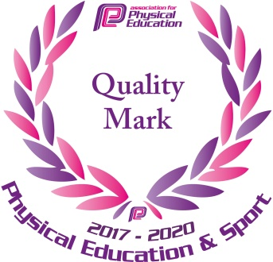**Cape Primary School**

**Physical Education Policy 2022- 2023**

Aims and Objectives

Physical Education develops the children’s knowledge, skills and understanding so that they can perform with increasing competence and confidence in a range of physical activities. These include dance, games, gymnastics, swimming and water safety, athletics and outdoor adventure activities. Physical Education promotes an understanding in children of their bodies in action. It involves thinking, selecting and applying skills and promotes positive attitudes towards a healthy lifestyle. Thus we enable them to make informed choices about physical activity throughout their lives.

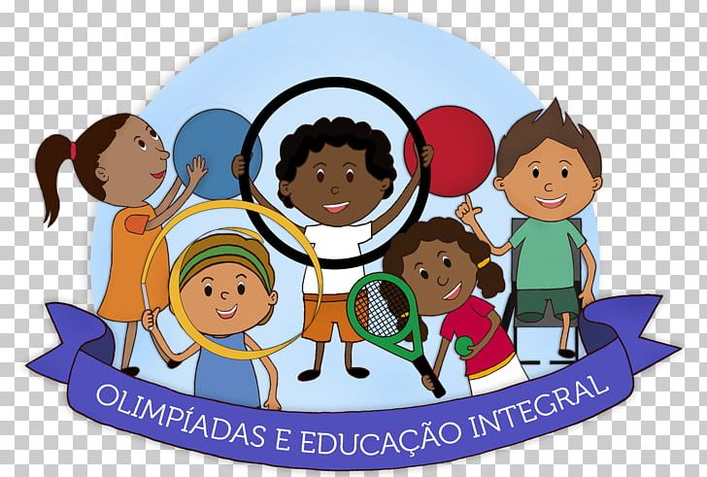Cape’s PE Core Values

**C**onfidence, competency and competition

**A**ctive, healthy lifestyles

**P**hysically active

**E**ngagement in competitive activities

The aims of PE are:

* to enable children to develop and explore physical skills with increasing control and co-ordination;
* to encourage children to work and play with others in a range of group situations;
* to develop the way children perform skills and apply rules and conventions for different activities;
* to increase children’s ability to use what they have learnt to improve the quality and control of their performance;
* to teach children to recognise and describe how their bodies feel during exercise;
* to develop the children’s enjoyment of physical activity through creativity and imagination;
* to develop an understanding in children of how to succeed in a range of physical activities and how to evaluate their own and others success.
* To develop children’s mental health and wellbeing

Teaching and Learning Style

We use a variety of teaching and learning styles in PE lessons. Our principal aim is to develop the children’s knowledge, skills and understanding and we do this through a mixture of whole-class teaching and individual/group activities. Teachers draw attention to good examples of individual performance as models for the other children and we encourage the children to evaluate their own work as well as the work of other children. Within lessons we give the children the opportunity to collaborate and to compete with each other. The children are given the opportunity to use a wide range of resources.

In all classes there are children of differing physical ability. Whilst recognising this fact, we provide suitable learning opportunities for all children by matching the challenge of the task to the ability of the child. We achieve this through a range of strategies:

* Setting common tasks that are open-ended and can have a variety of results.
* Setting tasks of increasing difficulty, where not all children complete all tasks.
* Grouping children by ability and setting different tasks for each group.
* Providing a range of challenge through the provision of different resources.
* Being open to adapt activities to suit the needs of the children.

**Implementation**

Physical Education begins when pupils start in our Early Years Foundation Stage and are encouraged to develop their Physical Development through planned continuous provision activities and specific programmes which support and develop their fine and gross motor skills. Pupils develop core strength, co-ordination and balance to enable them to reach the Early Learning Goal.

The National Curriculum is then used to support Physical Education throughout Key Stage One and Key Stage Two.

Pupils in Key Stage One are encouraged to continually develop fundamental movement skills and become increasingly competent and confident in a broad range of sports and activities.

Pupils in Key Stage Two are encouraged to continually apply and develop a broader range of skills, learning how to use them in different ways and link them to actions and sequence of movement. Pupils are taught how to enjoy communicating, collaborating and competing with each other.

**Key features of our curriculum:**

**End of EYFS**

* Good core strength.
* Good fine and gross motor skills
* Able to dress independently and have developed a range of basic life skills
* To have a good awareness of their own bodies and how they move.
* To understand that their bodies change during exercise (becomes hot etc.)

**End of KS1**

* The children have a good awareness of health and safety in P.E and in water safety to allow them to thrive.
* Children to have body awareness and the confidence to move in different ways (including agility, flexibility, coordination and stamina).
* Children to develop team work skills and understand how to get the best from each other.
* Develop the basic skills needed for the range of sports they will be exposed to in KS2 and life (e.g. throwing and catching)
* Being able to talk about the effects of exercise on the body and life

**End of Cape Primary School**

* Children to have developed at range of skills in multiple areas of the P.E curriculum.
* Children to have a good baseline to strive in Secondary skill and build on their talents.
* Children have all had the opportunity to join at least one extra- curricular activity throughout their time at Cape (afterschool, a lunchtime clubs etc.)
* Children to have developed confidence, sportsmanship, resilience and determination in order to achieve and that they can apply to other areas of their lives.
* Children are able to use their knowledge to determine what they are good at and then understand how they can improve.
* An enjoyment of swimming and be able to swim at least 25metres using a variety of strokes. Understand how to stay safe in and around water.
* To understand the need and fundamentals of a healthy lifestyle.
* Being able to talk about the effects of exercise on the body in detail (including different muscle names and technical terminology) and how this impacts on their lifestyle choices.

**Future Life**

* For children to have an enjoyment of a range of Sports and Physical Education.
* To have a healthy and active lifestyle that they can maintain themselves throughout their adult lives.
* To be able to contribute to the wider community having gained the skills such as confidence, sportsmanship, resilience and determination that we have developed throughout Cape.
* For gifted and talented children and those who wish, to take part in competitions (Olympics and adult football championship teams) in adult’s life and join adult teams.

**British Values**

We aim to encourage and promote British values through our PE curriculum; taking into account both British values and Olympic legacy. Through PE lessons, sporting activities and external competitions we promote:

* Courage – having the self-belief and confidence to overcome adversity and face difficulty.
* Equality – showing respect and humility towards all those around you in the spirit of fair play.
* Inspiration – to be motivated by the achievements and actions of others and to be a positive example to others.
* Reflection – students are asked to reflect on their actions and performance, thinking about how this may affect others in their team.
* Determination – students are challenged to give 100% effort in lessons and have an ethos of encouraging others as they should in life.

**Adaptive Teaching**

At our school we teach PE to all children, whatever their ability. PE forms part of the school curriculum policy to provide a broad and balanced education to all children. Through our PE teaching we provide learning opportunities that enable all pupils to make progress. We do this by setting suitable learning challenges and responding to each child’s different needs. Assessment against the National Curriculum allows us to consider each child’s attainment and progress against expected levels.

We aim to encourage all pupils to reach their full potential through the provision of varied opportunities. We recognise that our curriculum planning must allow pupils to gain a progressively deeper understanding and competency as they move through our school. Students are challenged and their ability is stretched to encourage them to reach their full potential and increase their personal fitness. We encourage children to take risks, to further their own personal boundaries in a safe and secure environment. Teachers are encouraged to imbed the principle of STEP for differentiating activities and encourage pupils to understand and challenge their selves in their own learning.

**S-** change the **S**pace available.

**T-** change the **T**ime allowed

**E-** change the **E**quipment e.g. softer/larger balls, different sized bats etc.

**P-** change the **P**eople e.g. size of the groups.

**Equipment and Resources**

The majority of PE equipment is currently stored in the PE cupboard near the Junior Hall and in the outdoor cupboard in the Junior playground. A list of the equipment is displayed on the doors for staff to see what we have available. The equipment is labelled and in clear sections of the cupboard. Teachers have the responsibility of ensuring equipment is put back correctly and safely. Resources to support planning and Health and Safety (including the afPE Safe Practice guidance) are stored in an additional PE cupboard in the Junior Hall.

A ‘fix me’ equipment book is attached to the wall in the PE cupboard in the Junior Hall. It is the responsibility of all staff to record any damaged equipment/resources, including those in both the Junior and Infant Halls. It will then be the responsibility of the PE coordinator to ensure the equipment/resources are either fixed or replaced.

All PE equipment is checked by an external company annually and a comprehensive report is drawn up and a programme of repairs is implemented.

**Health and Safety**

Teachers will ensure the teach children about Health and Safety through a series of PE lessons by using the afPE Safe Practice Guidance document (Found in the resources cupboard in the Junior Hall)

Risk assessments will be completed for the Junior and Infant Hall and the Outdoor Area. These will be re-evaluated every academic year.

**Clothing**

All children are required to come to school dressed in appropriate PE/Sports kit. The recommended kit is set out in the school prospectus. Trainers or pumps must be worn for outdoor activities and indoor game. When teaching Gymnastics and Dance children should be bare feet (not stockings, socks or tights.)

Staff should also promote the wearing of appropriate clothing for PE lessons. At a minimum staff should wear appropriate footwear and the school polo shirts that have been provided by the school. Staff should also be bare foot when teaching Gymnastics and Dance.

Pupils who do not have the right PE kit should NOT be excluded from PE lessons. They should be encouraged to take part in the lesson until it is not safe to do so. Children can take part in a scoring system, supporting groups, completing their PE Learning Logs etc.

**Jewellery and Hair**

All jewellery must be removed before any physical activity takes place and children that have recently had their ears pierced must cover the studs (front and back) with masking tape. Teachers are not required to tape or remove any earrings. Taping may be done at home for younger children or prior to the lesson for older children. Religious jewellery needs to be taped down or covered with a sweat band/long sleeve top.

Long hair must be tied back. Those children wearing headscarves for religious reasons will need to fix these at the sides or replace them with a sports Hijab.

**Environment and Equipment**

Before a PE lesson can take place, children will be encouraged to check their surrounding area to ensure it is safe to do so. Use the ‘!’ posters to identify any risks within the environment.

Children are also encouraged to participate in the setting up of lessons and equipment i.e. gymnastic apparatus, BUT all teachers will need to check that the equipment has been set up properly and is in good order.

During gymnastic lessons, ensure footwear is cleared away (under benches etc.), mats are equally spaced and children are aware health and safety surrounding gymnastics and performing.

If in doubt, reduce the space being used.

**First Aid**

It is the reasonability of the class teacher to take the red first aid bag to every PE session. These bags include the care plans and medication of those children who require them.

If, during a PE session, a child requires first aid, a first aider will be called for and then first aid will be given and the school policy will be followed.

**Concussion**

If you believe a child has suffered concussion please follow the protocols set by the afPE Safe Practice Guidance.

**Recognise** the signs, symptoms and the danger signs of potentially more serious brain injury.

**Remove** immediately from further participation in the lesson, activity or match. Do not leave alone. The child needs to be seen by a doctor/medical professional as soon as possible.

**Recover-** give time- avoid sports activity, running, cycling, swimming, fitness. Minimum of 14 days rest is advised unless cleared to return earlier by a doctor (parental responsivity to obtain this)

**Return-** students should return to academic studies before returning to physical activity, sometimes symptoms may be prolonged.

**Gradual return to participation-** if symptom free following the recommended 14 day recovery phase a gradual return to activity should be implemented.

*WHEN IN DOUBT-SIT THEM OUT*

*KEY NOTE- Trust your professional judgement regarding Health and Safety.*

**Evaluation and Assessment**

The assessment of P.E. is an integral part of teaching. It allows teachers to identify what has been learnt and to monitor pupils’ progress. Assessment should also diagnose and identify ways of over- coming particular learning difficulties. Teaching staff are to use a ‘Practical Evidence Book’ where picture evidence is collected and annotated where necessary. Teachers will use the schools marking policy to assess children’s confidence in different areas of PE. They will then use this to inform their judgement when completing the assessment tracker every half term.

**Equal Opportunities**

All children will be given equal access to P.E. irrespective of race, gender, creed, level of ability or nationality. Mutual respect and tolerance for all cultures will be promoted through the study of P.E.

**PE Learning Logs**

Every child will have a PE Learning Log that should be used to support their learning.

If for any reason, a PE lesson cannot take place, pupils will use their PE Learning Logs to:

* Create new games/rules/gymnastic sequences
* Write self/peer evaluations

**Extra-Curricular Clubs and Competitions**

All children will be encouraged to take part in different lunch time clubs ran by WBA federation. The groups of children attending these clubs will be changed every half term to ensure all children have the opportunity to have a go.

Competitions that are run by Sainsbury’s Games will take place throughout the academic year. Children will be encouraged to ‘sign up’ if they want to participate.