The Cape Primary School

**Location and Knowledge**

**Place and Knowledge**

**Human and Physical Geography**

**Geographical Skills and Fieldwork**

**Geography in the Early Years**

**EYFS Curriculum….**

**22-36 months**

Enjoys playing with small-world models such as a farm, a garage, or a train track.

Notices detailed features of objects in their environment.

**30-50 Months**

Can talk about some of the things they have observed such as plants, animals, natural and found objects

Uses positional language.

**40-60 Months**

Looks closely at similarities, differences, patterns and change.

Can describe their relative position such as ‘*behind*’ or ‘*next to*’.

**ELG**

Children know about similarities and differences in relation to places, objects, materials and living things.

They talk about the features of their own immediate environment and how environments might vary from one another.

They make observations of animals and plants and explain why some things occur, and talk about changes.

**Children use everyday language to talk about position and distance to solve problems.**

**The Skills…**

Children will learn how to explore, observe, problem solve, predict, think critically, make decisions and talk about the creatures, people, plants and objects in their natural environment.

**But Why?….**

The early learning goals at EYFS aim to support children onto make sense of their physical world and their community by exploring, observing, and finding out about people, places, technology and the environment.

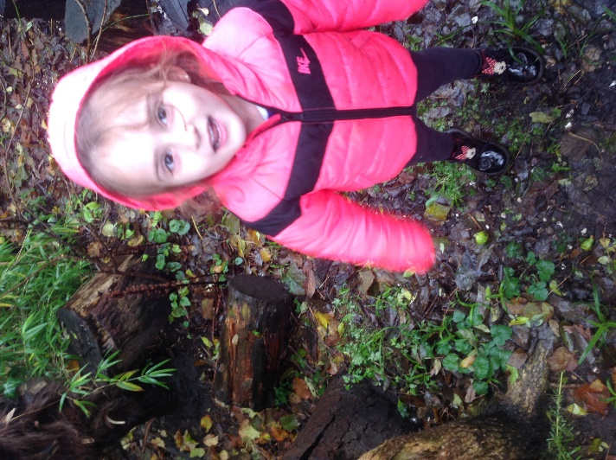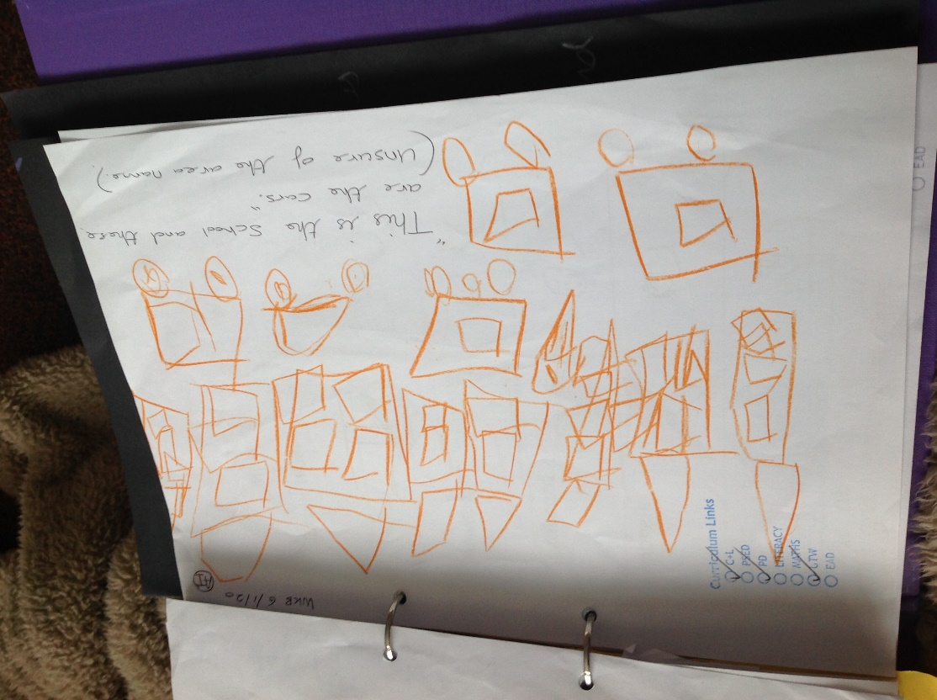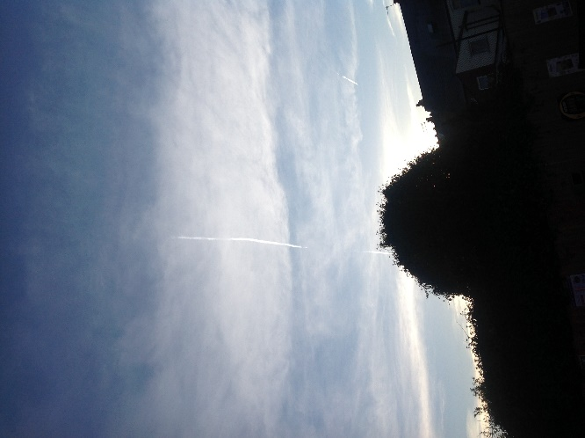

“The garden is wet and cold and the animals are hiding in the bug house… the bug house will be nice and warm for the bugs like my home”

Recognising the differences and similarities in different environments

Children are commenting and drawing about the things they can see in their local environment.

“The aeroplane is going up into the sky. People are going to Pakistan. Pakistan is really hot; you have to wear sun cream, sometimes you wear sun cream at home”

Children are making comments about the world around them and able to talk about the differences in temperatures of different countries.

**Geography looks like this….**

**Progression into Year 1…**

To recognise similarities and differences in their immediate environment

Name the countries making up the British Isles, with their capital cities (label Birmingham)

To recognise similarities and differences in their immediate environment (how has their environment changed?)

To talk about people and places beyond their local environment (where does our food come from?)

To talk about where they live

To talk about and find their way around the local area showing an awareness of where buildings are and what they are used for.

To express their views on features of the environment of their locality-what they like/dislike

To show their knowledge, skills and understanding in studies at a local scale

To use resources that are given to them, and their own observations, to ask and respond to questions about the local area

Use basic geographical vocabulary to refer to

Key human features, including: city, town, village, factory, farm, house, office, port, harbour and shop (which features are found locally?)

To use resources that are given to them, and their own observations, to ask and respond to questions about the places where their food comes from.

Use basic geographical vocabulary to refer to

Key human features, including: city, town, village, factory, farm, office, port, harbour and shop in relation to how our food is grown and transported.

Use basic geographical vocabulary to refer to: key physical features, including: soil, valley, vegetation, season and weather in relation to how our food is grown.

Develop maps of the local environment.

Where are the shops located in Cape Hill?

Draw journeys the children go on. Journey to school. Journey to the shops.

Use maps, atlases, globes and digital/computer mapping (Google Earth) to locate Cape Hill

Use fieldwork to observe, measure and record the human and physical features in the local area using a range of methods including sketch maps, plans and graphs and digital technologies.

Draw the journey our food makes.

Use maps, atlases, globes and digital/computer mapping (Google Earth) to see the journey our food makes.