The Cape Primary School

**EYFS Curriculum….**

**30-50 Months**

Moves freely and with pleasure and confidence in a range of ways, such as slithering, shuffling, rolling, crawling, walking, running, jumping, skipping, sliding and hopping.

Mounts stairs, steps or climbing equipment using alternate feet.

Walks downstairs, two feet to each step while carrying a small object.

Runs skilfully and negotiates space successfully, adjusting speed or direction to avoid obstacles.

Can stand momentarily on one foot when shown.

Can catch a large ball.

Beginning to move rhythmically. Imitates movement in response to music (EAD)

**40-60 Months**

Experiments with different ways of moving.

Jumps off an object and lands appropriately.

Negotiates space successfully when playing racing and chasing games with other children, adjusting speed or changing direction to avoid obstacles.

Travels with confidence and skill around, under, over and through balancing and climbing equipment.

**ELG**

Children show good control and co-ordination in large and small movements.

They move confidently in a range of ways, safely negotiating space.

They represent their own ideas, thoughts and feelings through dance (EAD)

Children know the importance for good health of physical exercise, and a healthy diet, and talk about ways to keep healthy and safe. They manage their own basic hygiene and personal needs successfully, including dressing and going to the toilet independently.

**Dance**

**Gymnastics**

**Striking and Fielding**

**Invasion Games**

**Health and Self Care**

**PE in the Early Years**

**But Why?….**

Children need to develop their core strength, control, balance and co-ordination to support their gross motor movements and also their fine motor skills, including the ability to write.

Children need to be able to dress independently and have a good awareness of their own bodies and how to look after theirselves.

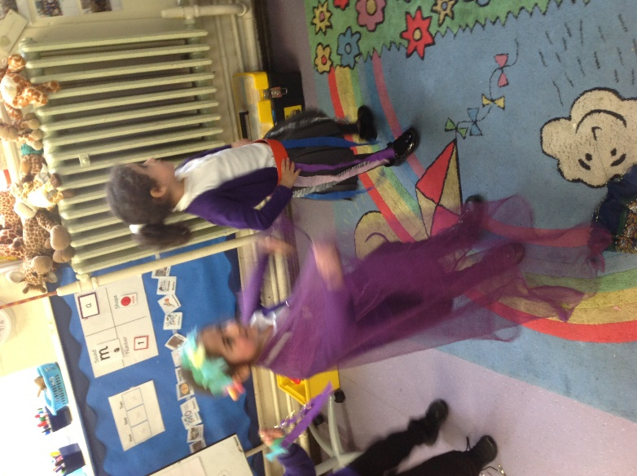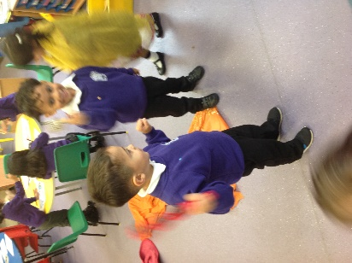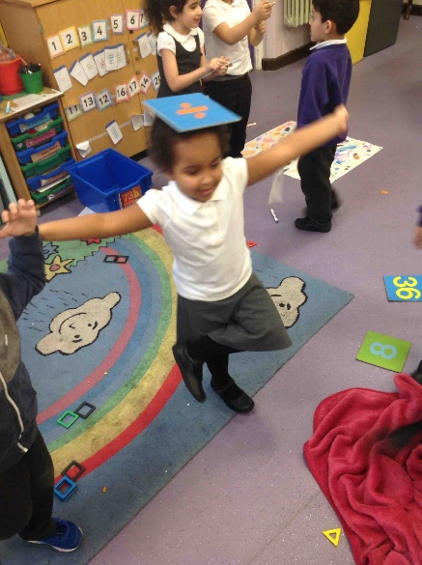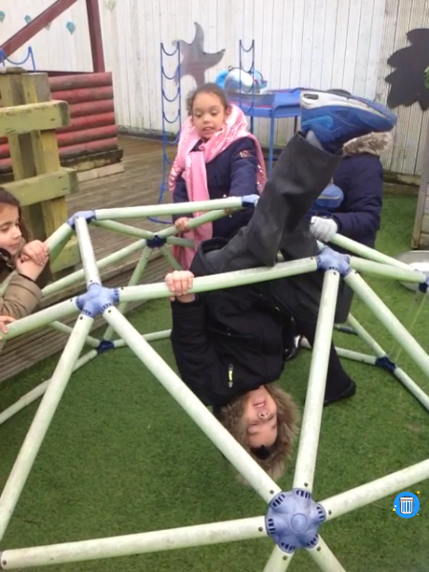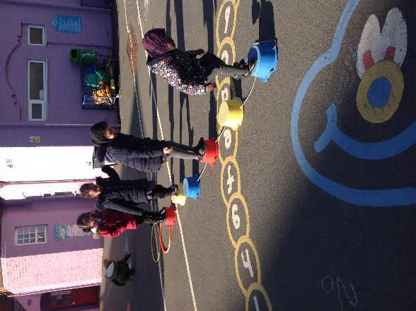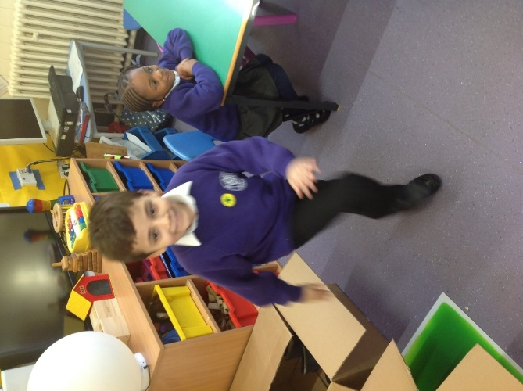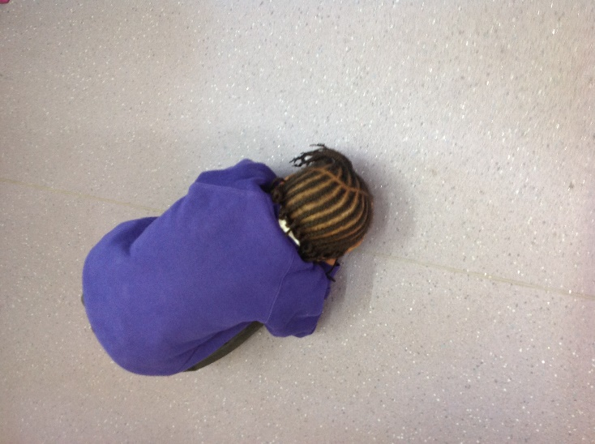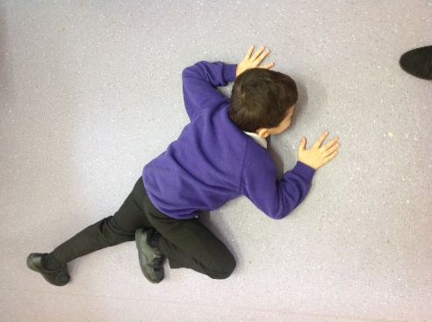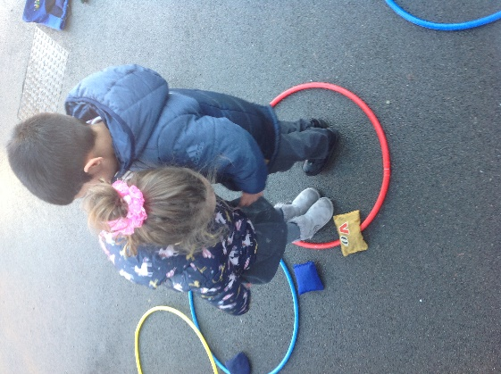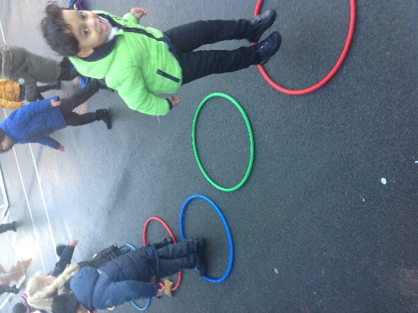

Making up their own dance moves during Dawaii, responding to music

“I can balance on my foot”

Developed core strength and ability and balance.

Exploring different ways of travelling- under, over, through. Negotiating space and working in partnership with others.

Travelling with confidence and showing good control in large and small movements.

**PE looks like this….**

**Progression into Year 1…**

**Dance: Copy dance moves. Make up a short dance, after watching one. Dance imaginatively. Change rhythm, speed, level and direction.**

**Gym: Make body tense, relaxed, curled and stretched, showing some tension. Begin to work on alone/with someone to make a sequence of shapes/travels. Climb safely, showing some shapes and balances when climbing. Keep balance travelling in a range of ways along bench, spots, mat etc. Roll in stretched/curled positions e.g. ‘log’ and ‘egg rolls’**

**Striking and Fielding: Show some different ways of hitting, throwing and striking a ball**

**Hit a ball or bean bag and move quickly to score a range of points (further distance scores more points.) Play as a fielder and get the ball back to a STOP ZONE. Begin to follow some simple rules (carrying the bat, not over taking someone)**

**Invasion Games: Throw underarm, bounce & catch ball by self & with partner. Kick/stop a ball using a confident foot while static. Run straight and on a curve and sidestep with correct technique. Begin to follow some simple rules.**