The Cape Primary School

**EYFS Curriculum….**

**30-50 Months**

Understands that equipment and tools have to be used safely (Health and Self-Care, PD)

Uses various construction materials. Beginning to construct, stacking blocks vertically and horizontally, making enclosures and creating spaces. Joins construction pieces together to build and balance. Realises tools can be used for a purpose (EAD)

**40-60 Months**

Shows understanding of the need for safety when tackling new challenges, and considers and manages some risks. Shows understanding of how to transport and store equipment safely. Practices some appropriate safety measures without direct supervision (Health and Self-Care, PD)

Uses simple tools to effect changes to materials. Handles tools, objects, construction and malleable materials safely and with increasing control (Moving and Handling, PD)

Uses familiar objects and common shapes to create and recreate patterns and build models (Shape, Space and Measure)

Understands that different media can be combined to create new effects. Manipulates materials to achieve a planned effect. Constructs with a purpose in mind, using a variety of resources. Uses simple tools and techniques competently and appropriately. Selects appropriate resources and adapts work where necessary. Selects tools and techniques needed to shape, assemble and join materials they are using. (EAD)

Create simple representations of events, people and objects (EAD)

**ELG**

Children use what they have learnt about media and materials in original ways, thinking about uses and purposes. They represent their own ideas, thoughts and feelings through design and technology (EAD)

They safely use and explore a variety of materials, tools and techniques, experimenting with colour, design, texture, form and function (EAD)

**Designing**

**Making**

**Evaluating**

**Technical Knowledge**

**D&T in the Early Years**

**But Why?….**

D&T in the Early Years can enable children to make sense of the 'made world' in which they live. By making, changing and designing things for themselves, children gain a greater understanding of their world and the knowledge of being able to change and modify their environment. Design is not just about drawing, but about thinking. Creating a pizza or designing a new Lego structure require no drawing, but both involve some experience, some imagination and a willingness to change and modify ideas. Technology, on the other hand, is about doing - making something for a purpose. It involves putting ideas into practice and having an awareness of the possibilities and limitations of different materials. Children need to experience at first hand the consequences of the decisions they have made, rather than quickly being shown by an adult how to get it 'right'. Purposeful making involves creativity, imagination and fun - as well as making mistakes.

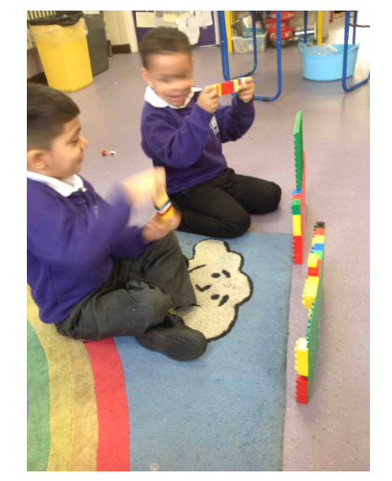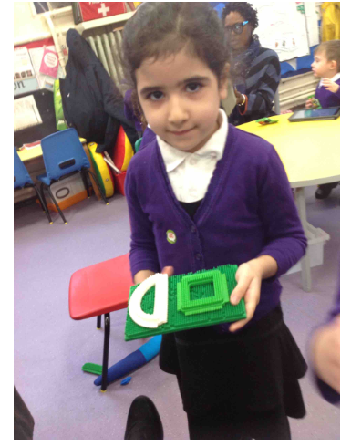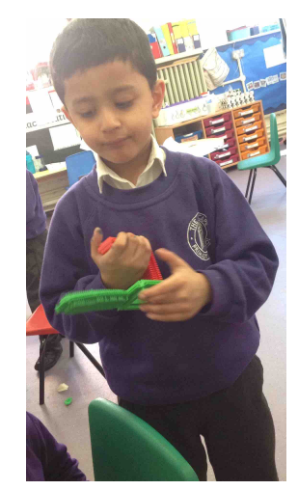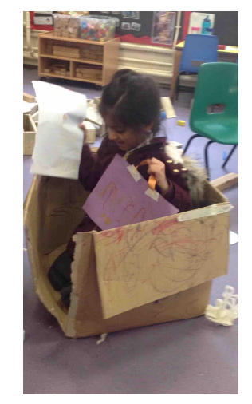

**Progression to Year 1**

**Evaluating**

-talk about their design ideas and what they are making

-suggest how their products could be improved

-say how well his/her designs and product met the given design criteria using a simple yes or no answer

-Pupils should be able to say: what products are, who products are for, what products are for, how products work, what materials products are made from using a vocabulary bank, what they like and dislike about products

-to know what ingredients products are made from using a vocabulary bank

**Technical Knowledge**

-be able to choose from a word bank, the correct technical vocabulary for the projects they are undertaking

-know how freestanding structures can be made stronger, stiffer and more stable using given prompts

-to know about the movement of simple mechanisms such as levers, sliders

-children should know that food ingredients should be combined according to their sensory characteristics

-name and sort foods into the five groups in the Eatwell Guide

-know that everyone should eat at least five portions of fruit and vegetables every day

-know how to prepare simple dishes safely and hygienically, without using a heat source

-know how to use techniques such as cutting, peeling and grating

-read a simple scale to measure and weigh out ingredients.

-understand that food comes from plants and animals and has to be farmed, grown or caught.

**Designing**

-state what they are making in simple terms

-say whether their products are for themselves or other users

-describe what their products are for in simple terms

-say how their products will work

-say how they will make their products suitable for their intended users

-use simple design criteria to help develop their ideas

-generate simple ideas by drawing on their own experiences

-use existing products to help come up with ideas

-communicate ideas by talking and drawing

-model ideas by exploring materials, components and construction kits and by making mock- ups

-use information and communication technology, where appropriate, to communicate their ideas

**Making**

-plan by suggesting what to do next

-choose from a small range of tools and equipment, explaining their choices verbally

-select from a range of materials according to their characteristics

-cut materials safely using materials provided.

-measure and mark out using non-standard measurement

-demonstrate modelled joining techniques (e.g. combining materials to strengthen)

-assemble, join and combine materials with support

-create products using levers

-children should follow procedures for safety and hygiene

Awais and Muayad have constructed using Lego .

"Its road blocks and you sit here and can watch the tv" Awais says showing me a different construction part.

"This is a square to and this rectangle tv for all the people to see in road blocks" Awais says

"Awais... I'm the winner!!!!" Says Muayad

"No I'm the winner" replies Awais

They pretend their Lego blocks are controllers and they pretend to push buttons

"You win a car race!" Says Muayad waving his hands up in the air

'Let's play running game now!" Replies Awais

Both boys begin moving their controllers up and down like they are running

"You win!" Shouts Muayad

Mariah has been using the stickle brick to construct, joining pieces together and adapting as her story continues.

"This is the swimming pool and you can go in this swimming pool but I will go in the hot tub"

I say 'I like the idea of a hot tub, I've never been in one before what happens?'

"I've been in the hot tub before you have bubbles in there"

She looks back at what she has made "in the swimming pool there are sharks you can swim in there with he sharks but it's ok because they in the box and can't eat you"

I reply 'oh that's good then because I don't want to be eaten by the shark!'

"Ok you can be in the hot tub then that's ok!"

"Are you eating healthy?" Aleem asks

Why should I eat healthy? I ask

"Because I have a detector and it can detector (detect) if you are eating healthy food"

He places his detector on my leg "you are eating healthy food, lots of oranges, keep up the good work"

Aleem checks Awais.

"Awais isn't healthy the detector says he's eating chocolate and now it's broken"

Aleem has constructed his ‘detecter’ and adapted it to create a handle

Constructed a boat using a cardboard box, using scissors and tape to amend the model. "I'm going to America in my boat, if you want to come to America you have to put your coat on because you need sleeves because it's cold and winter. I think I've got everything I need, my bag and my list."

What's on your list? "1) blanket 2) food 3) bed 4) pet" "When I get to America i can go in the swimming pool but when it's summer, and there's a slide.

**DT looks like this….**