The Cape Primary School

**Non Specific**

**Christianity**

**Islam**

**Sikhism**

**RE in the Early Years**

**But Why?….**

The processes of exploration and reflection are important for the child.

Learning from other views, cultures and beliefs supports children in developing their views and beliefs about themselves, their family and community.

Learning about other views, beliefs and cultures supports children in developing positive attitudes towards them.

**EYFS Curriculum….**

**30-50 Months**

Confident to talk to other children when playing, and will communicate freely about own home and community. (PSED- Self Confidence and Awareness)

Shows interest in the lives of people who are familiar to them. Remembers and talks about significant events in their own experience. Recognises and describes special times or events for family or friends. Shows interest in different occupations and ways of life.

Knows some of the things that make them unique, and can talk about some of the similarities and differences in relation to friends or family. (UTW- People and Communities)

* 1. **months**

Confident to speak to others about own needs, wants, interests and opinions. Can describe self in positive terms and talk about abilities. (PSED- Self Confidence and Awareness)

Enjoys joining in with family customs and routines. (UTW- People and Communities)

**ELG**

Children talk about how they and others show feelings, talk about their own and others’ behaviour (PSED- Managing Feelings and Behaviour)

They use past, present and future forms accurately when talking about events that have happened (C+L- Speaking)

Children talk about past and present events in their own lives and in the lives of family members. They know that other children don’t always enjoy the same things, and are sensitive to this. They know about similarities and differences between themselves and others, and among families, communities and traditions. (UTW- People and Communities)

**The Skills…**

Children are able to talk about their own self and their families. They can recall familiar events and family traditions.

They are aware of their own beliefs and those of others and are sensitive to these.

Children can talk about their own abilities and reflect on what they can do to achieve.

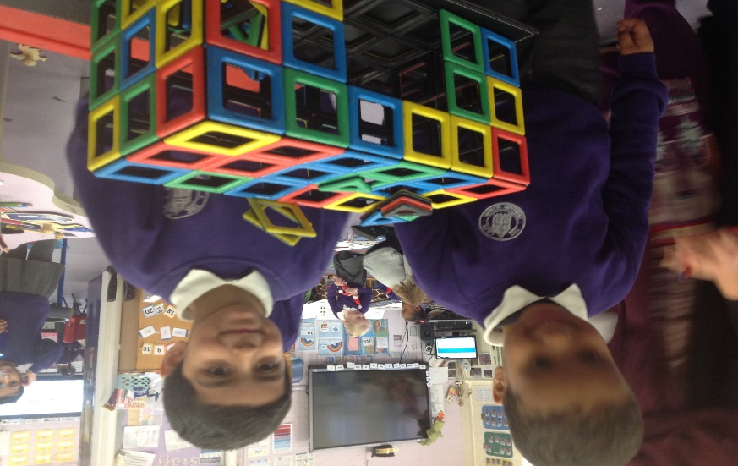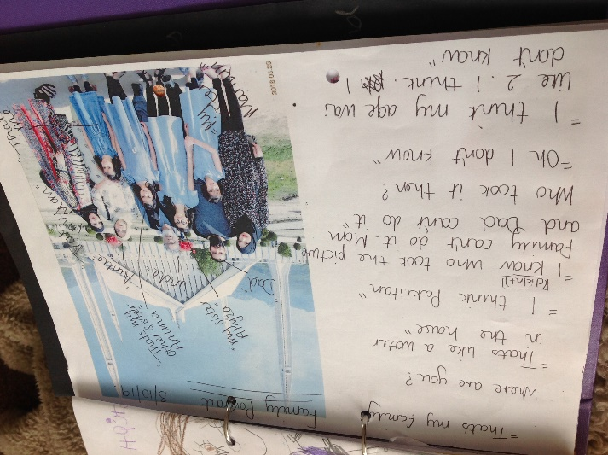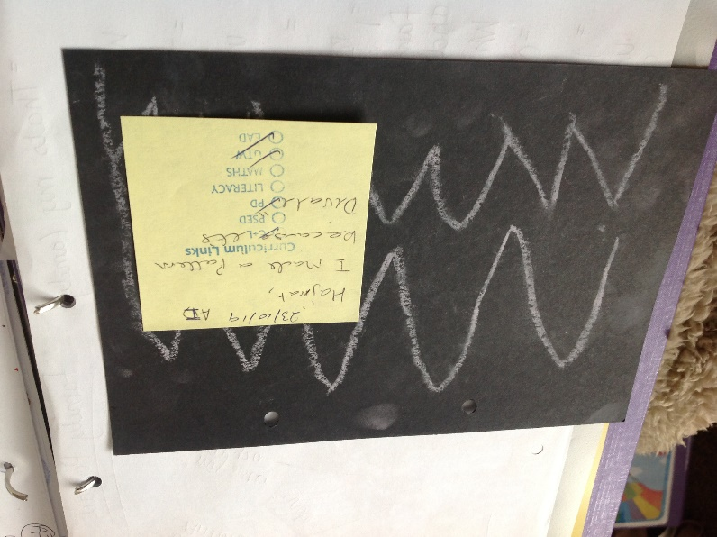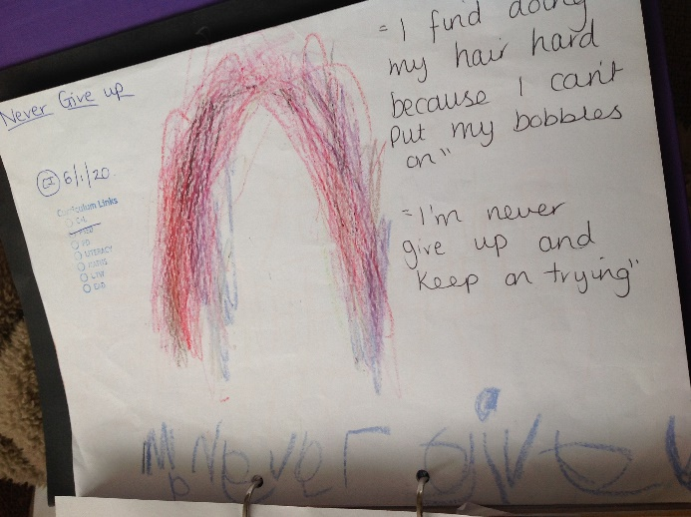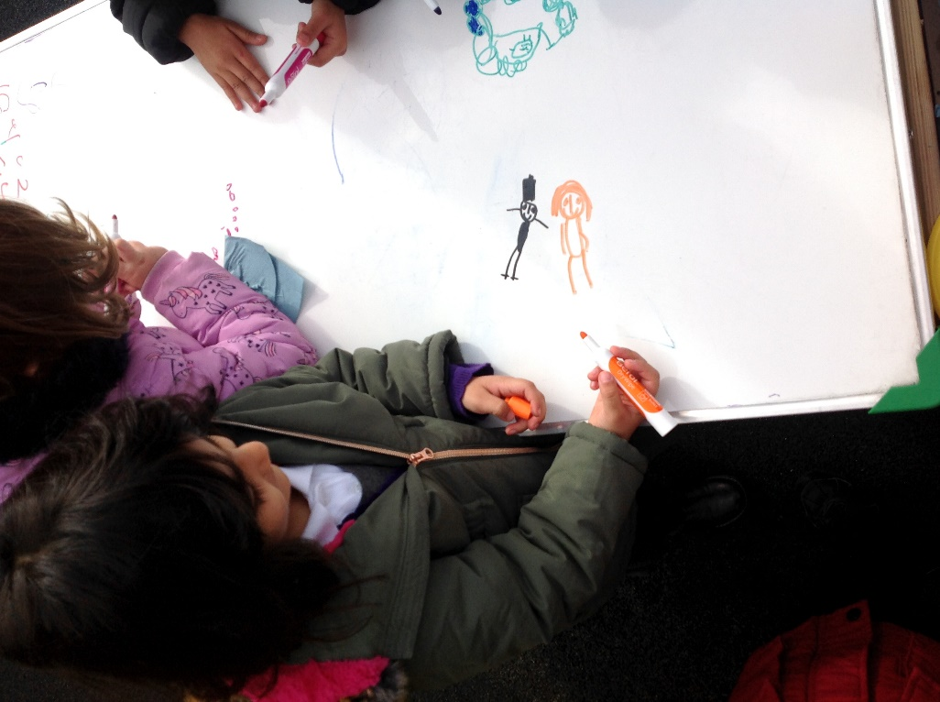

Diwali Rangoli Pattern.

Children joining in with cultural traditions.

Children are talking about their own abilitites and things they need to work on. They support each other to ‘Never Give Up’ and ‘Keep on Trying’

**“This is you, you getting married and you have a white dress. My mom and dad got married but my mommy have a red dress. She is Muslim”**

Children have constructed **“This is the mosque; this is where you pray” “Muslims pray in the mosque”**

Children are able to talk about their experiences and make links between different religions

**Living In Harmony: How do we show that we care?** **Sikhism,** **Islam** and **Christianity**

- respond sensitively to stories about God and humanity from different religions.

- say which books are special to the religion I am learning.

- recognise pictures and some objects and identify the religion they are related to.

**Questions that puzzle us. Non-specific**

- talk about what I find interesting or puzzling.

- ask simple questions about belonging to a religion.

- say what matters to me and explain why.

**Celebrating. Non-specific**

-talk about a special celebration and how celebration makes people feel.

-talk about ways in which people celebrate and how they like to celebrate.

-share in talking about special objects or clothes used at a baptism and how people feel at a baptism.

-talk about a time of celebration and show something they have made that links to the celebration.

-talk about a festival story and say something about how people celebrate the festival.

-identify with the feelings religious people have on special days

-think and talk about their own special occasions

**Myself: Who am I? Non-specific**

-talk about things that happen to me.

- talk about what is important to me and to other people.

- say what matters to me and explain why.

-reflect on and show awareness of themselves and others as being special

and unique individuals.

**Celebrations why do Christians give gifts at Christmas**? **Christianity**

- use the right names for things that are special to Christians

- say which books are special to the religion I am learning.

- remember a Christian story and talk about it.

- recognise religious art, symbols and words, and talk about them.

- talk about what I find interesting or puzzling.

- ask simple questions about belonging to a religion.

- respond sensitively to stories about God and humanity from different religions.

**Beginning to learn Islam: What can we learn from Muslims in Sandwell? Islam**

- respond sensitively to stories about God and humanity from different religions.

- recognise religious art, symbols and words, and talk about them.

- say which books are special to the religion I am learning.

- ask simple questions about belonging to a religion.

**Progression into Year 1…**

**RE looks like this….**