The Cape Primary School

**Biology (Animals and Planets)**

**Chemistry**

**Physics**

**Working Scientifically**

**Science in the Early Years**

**EYFS Curriculum….**

**30-50 Months (UTW- The World)**

Comments and asks questions about aspects of their familiar world such as the place where they live or the natural world.

Can talk about some of the things they have observed such as plants, animals, natural and found objects.

Talks about why things happen and how things work.

Developing an understanding of growth, decay and changes over time.

Shows care and concern for living things and the environment.

Beginning to be interested in and describe the texture of things (EAD)

**40-60 Months (UTW- The World)**

Looks closely at similarities, differences, patterns and change (links to all areas of Science)

Experiments to create different textures.

**ELG (UTW- The World)**

Children know about similarities and differences in relation to places, objects, materials and living things. They talk about the features of their own immediate environment and how environments might vary from one another. They make observations of animals and plants and explain why some things occur, and talk about changes.

**But Why?….**

Children will start to gain the science knowledge that they'll build on throughout their primary school years, such as developing their skills of exploring, observation, problem solving, prediction, critical thinking and discussion. It’s called ‘knowledge and understanding of the world’.

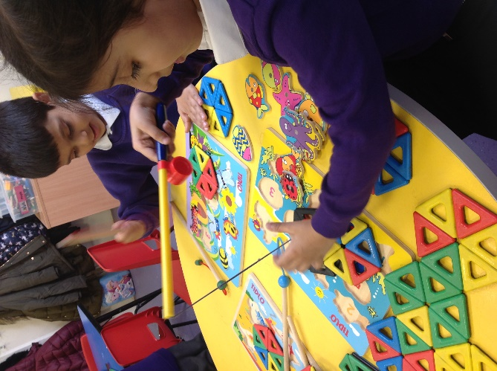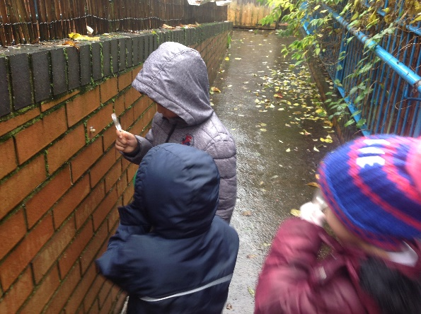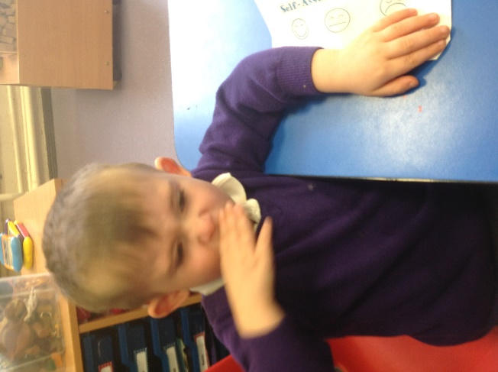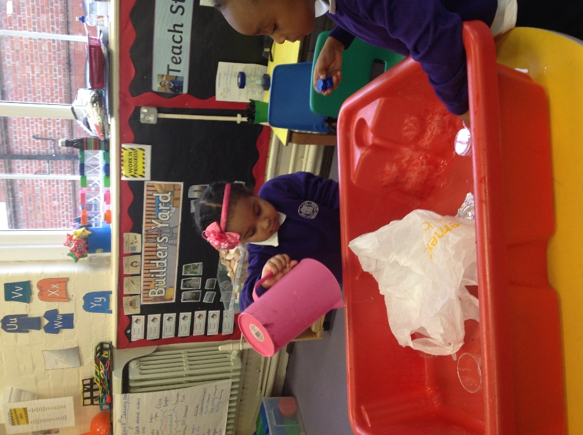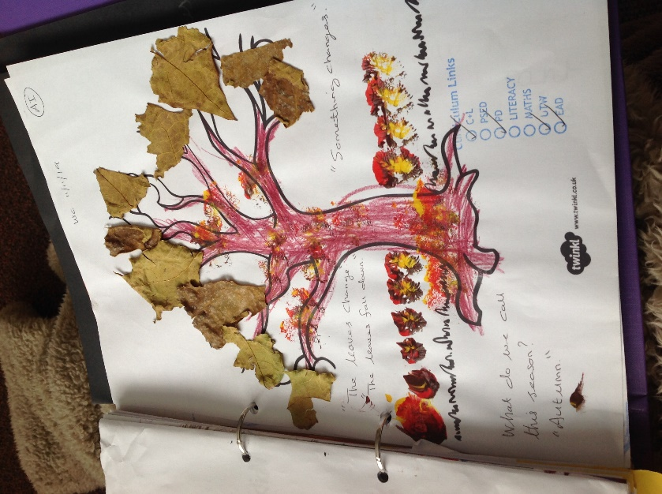

**“The magnetics make it stick together with the puzzle”**

Children beginning to talk about different materials and how they work.

Exploring in the secret garden

**“I see bug (snail) it live in garden, no house like me”**

Children know about the differences and similarities with living things.

Using our senses **“I eat it… no like it”**

Children are exploring their own bodies and their senses. Children can identify which body part relates to their senses.

Exploring materials- finding a new helmet for Baby Bear

**“We can use a plastic bag. It will keep baby bear dry.” Why will it keep him dry? “It’s waterproof and won’t get water in his helmet”**

Beginning to talk about properties of different materials.

**“The leaves change… the leaves fall down.” What do we call this season? “Autumn”**

Children are beginning to talk about the different seasons and noticing changes within their environment.

**Science looks like this….**

**Progression into Year 1…**

**Biology (Plants)** Identify and name common wild and green plants, including deciduous and evergreen trees. Identify and describe the basic structure of a variety of common flowering plants including trees. Explore and compare the differences between things that are living, dead and things that have never been alive.

**Biology (Animals)** Identify and name a variety of common animals including fish, amphibians, reptiles, birds and mammals. Identify and name a variety of common animals that are carnivores, herbivores and omnivores. Describe and compare the structure of a variety of common animals (fish, amphibians, reptiles, birds and mammals, including pets). Identify, name, draw and label the basic parts of the human body and say which part of the body is associated with each sense.

**Chemistry (Materials and their properties)** Distinguish between an object and the material from which it is made. Identify and name a variety of everyday materials, including wood, plastic, glass, metal, water and rock. Describe the simple physical properties of a variety of everyday materials. Compare and group together a variety of everyday materials on the basis of their simple physical properties

**Physics (Seasons)** Observe changes across the four seasons. Observe and describe weather associated with the seasons and how day length varies.

**Working Scientifically**. Ask simple questions when prompted. Suggest ways of answering a question. Make relevant observations. Conduct simple tests with support. With prompting, suggest how findings could be recorded. Recognise findings. Gather and record data. Use observations to suggest answers to questions.