The Cape Primary School

**Investigate and Interpret the Past (Historical Enquiry**

**Build an Overview of World History**

**Understand Chronology**

**Communicate Historically**

**History in the Early Years**

**EYFS Curriculum….**

**30-50 Months**

Can retell a simple past event in correct order. Uses talk to connect ideas, explain what is happening and anticipate what might happen next, recall and relive past experiences (Speaking)

Shows interest in illustrations and print in books and print in the environment (Reading)

Recites numbers in order to 10 (Number)

Developing an understanding of growth, decay and changes over time (The World)

Remembers and talks about significant events in their own experience (People and Communities)

**40-60 Months**

Explains own knowledge and understanding, and asks appropriate questions of others (Making Relationships)

Uses language to imagine and recreate roles and experiences. Uses talk to organise, sequence and clarify thinking, ideas, feelings and events (Speaking)

Knows that information can be retrieved from books (Reading)

Recognise some numerals of personal significance. Recognises numerals 1 to 5 (Number)

Uses everyday language related to time. Orders and sequences familiar events. Measures short periods of time in simple ways. (Shape, Space and Measure)

Looks closely at similarities, differences, patterns and change (The World)

Create simple representations of events, people and objects (Being Imaginative)

**ELG**

They use past, present and future forms accurately when talking about events that have happened (Speaking)

From one to 20, place them in order (Number)

Children talk about past and present events in their own lives and in the lives of family members. They know that other children don’t always enjoy the same things, and are sensitive to this. They know about similarities and differences between themselves and others, and among families.

**But Why?...**

The children will have a developed vocabulary they can draw upon later in school.

The children have a greater understanding of now and then and can talk about change over time. Children can discuss continuity and change.

Children can explain significance in their own language.

Children will be excited to talk about things that have happened in their life, and they’ll have more range to talk about why those things were special.

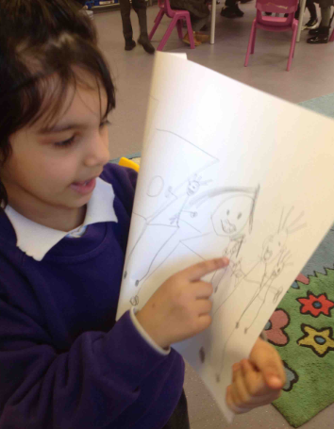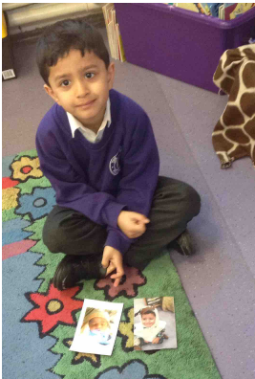

**Progression into Year 1…**

**Investigate and Interpret the Past (Historical Enquiry)**

-To look at objects, pictures and events from the past and ask questions i.e, “What were they used for?” “Which things are old/new?” and try to answer.

-To sort artefacts “then” and “now”

-To sort photographs into “then” and “now”

-To observe, explore and handle a range of sources to find out about the past and ask questions

-To Identify the fact that pictures, accounts and stories represent the past.

-To ask questions such as: what was it like for people? How long ago?

**Build an Overview of World History**

-To recount changes in own life over time.

-To begin to identify the main differences between old and new objects.

-To identify objects from the past (such as old toys)

-To explain how my local area was different in the past

**Understand Chronology**

-To place events/artefacts/photographs in order on a timeline showing some understanding of the passing of time.

-To label timelines with historical language older/newer

-To recount changes which have occurred in one’s own life.

-To use dates where appropriate.

-Describe things that happened to themselves and other people in the past.

**Communicate Historically**

-Use words and phrases such as long time ago, recently, when my parents/carers were children, years, to describe the passing of time.

-Use words: old, new, sort, then, now, past, present, older, newer, tram

Prableen told me she had drawn a picture of her family. She started to point and identify each person. "This is my mom. This is my dad this is my baby brother" what is your baby brothers name? "His name Anmol and this is my brother". Prableen do you have another brother? "Yes. Raman". Is Raman older than you or younger than you? She used her hand to show as she said "bigger". Where do you all live? "In my house". She pointed at the picture as she said this. Where is daddy now? "He's in the shop". Is that where he works? She nodded.

“I go swimming, I can swim in the pool on my own. I go with my family, my mom, dad, big sister and brother. I'm learning the rules of the swimming lessons. It's a lot of fun".

Aleem has brought in 2 pictures from home to share with the class during our lifecycle topic.

"I'm in the hospital because I'm getting born and I'm wearing a hat and a blanket. I'm a baby but now I'm 5 and big.

How have you changed?

"Because my birthday came and then my birthday I was 1, 2,3,4, and now I'm 5 and I'm going to be 6 on my next birthday."

"I can brush my teeth and I can put my clothes on by myself and do my bath and now I can do lots of talking, but when I was baby I didn't have teeth but now I got teeth"

**History looks like this….**