The Cape Primary School

**Basic Computer Skills**

**Text, Images & Multimedia**

**Understanding and Sharing Data**

**Programming & Computational Thinking**

**Online Safety & Digital Literacy**

**Computing in the Early Years**

**EYFS Curriculum….**

**30-50 Months**

Uses positional language (Maths- Shape, Space and Measure)

Knows how to operate simple equipment, e.g. turns on CD player and uses remote control. Shows an interest in technological toys with knobs or pulleys, or real objects such as cameras or mobile phones. Shows skill in making toys work by pressing parts or lifting flaps to achieve effects such as sound, movements or new images. Knows that information can be retrieved from computers (UTW-Technology)

**40-60 Months**

Knows that information can be retrieved from books and computers (Literacy- Reading)

Can describe their relative position such as ‘*behind*’ or ‘*next to*’ (Maths- Shape, Space and Measure)

Completes a simple program on a computer. Uses ICT hardware to interact with age-appropriate computer software. (UTW- Technology)

**ELG**

Use everyday language to talk about position (Maths- Shape, Space and Measure)

Children recognise that a range of technology is used in places such as homes and schools. They select and use technology for particular purposes (UTW- Technology)

**The Skills…**

Understand that a range of technology is used for a purpose.

Recognise, understand and use different digital devices.

Recognise and use a mouse, touchscreen or appropriate access device to target and select option on screen.

Recognise key parts of a keyboard e.g. spacebar, numbers and letters.

Add text to a document using the keyboard/touch screen.

**But Why?….**

Helping children to understand their place in a world that is increasingly dominated by technology. We need to help them make sense of this world, as well as planting the seeds for their understanding of the implications of technology in their lives and society. This is the start of ‘digital literacy’ and it extends into Key Stage 1, where children are taught to ‘recognise common uses of information technology beyond school’.

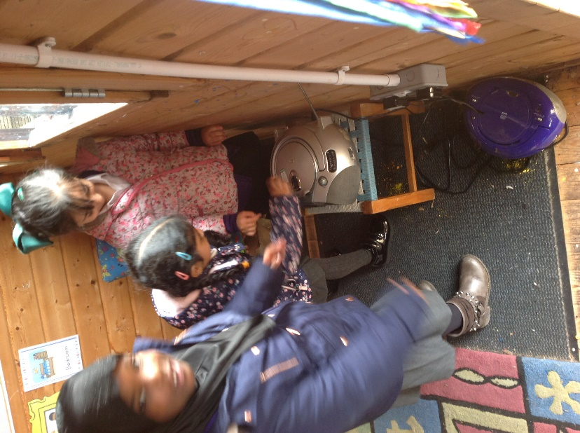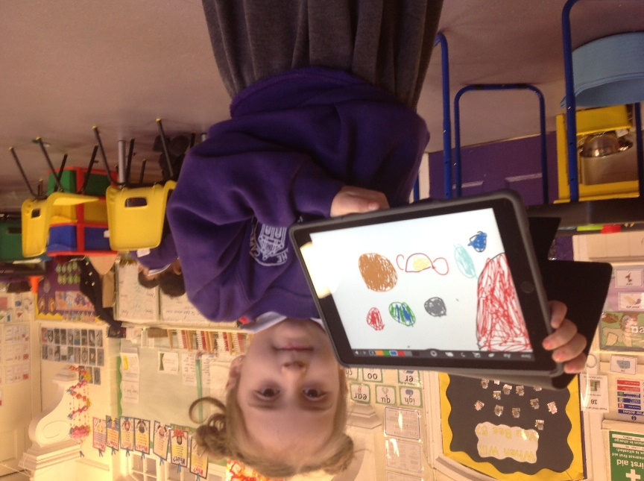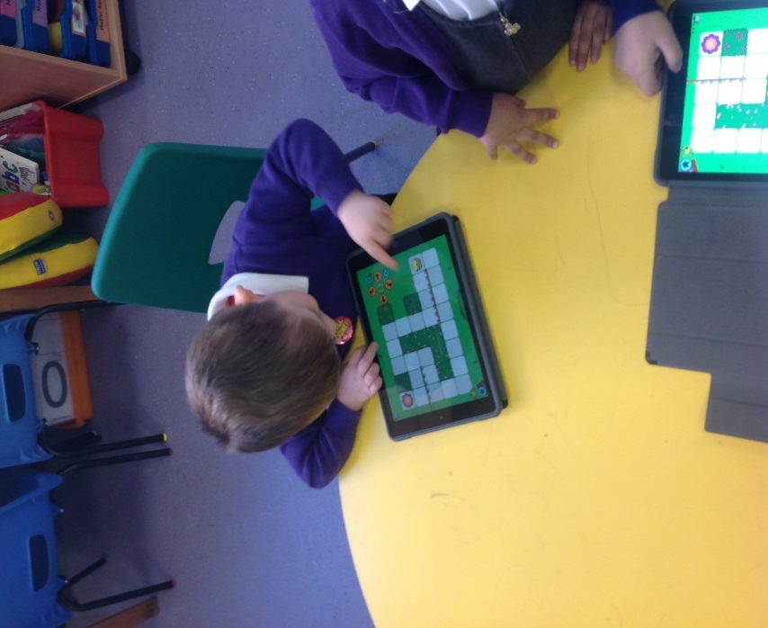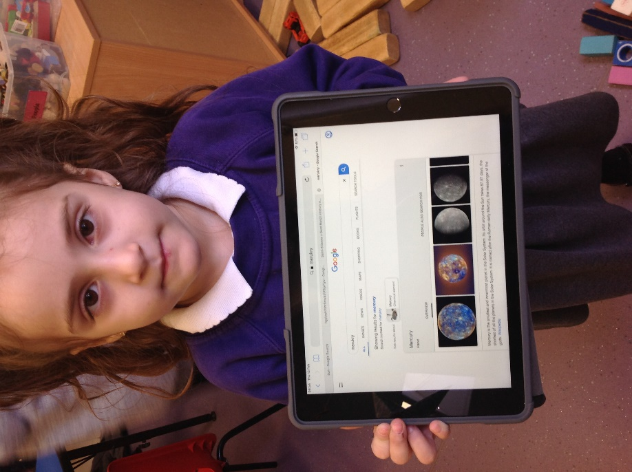

Children can confidently use the iPads to complete simple apps including games and drawing apps. Children can navigate through the iPads confidently, knowing how to turn them on and off and how to charge them up. Children understand how to take pictures and videos and can play these back. Some children understand how to use ‘Siri’ to find information.

Children understand on how to turn on cd players, and technological toys including cameras, torches and beebots.

Children are aware of the search engine ‘Google’ to find information. Children are beginning to touch type on the keyboard to find information.

**Computing looks like this….**

**Labelling and Classifying**

I can create a label for a self portrait, with little support. I can log onto the computer. I can open the correct webpage. I can drag the parts of the body into the correct position (with little support) I can use a computer to sort animals.

**Understanding Instructions**

I know that machines and devices can be controlled. I can explain how to control toys. I can sort toys into those that use power and those that don’t. I can give clear directions. I understand why it is important to give clear directions. I can write a set of instructions. I can write instructions in an agreed format. I can follow instructions

I can predict the outcome of a set of instructions and test the results.

**The information Around Us**

I can name the different sources where I can receive information from. I can use the voice recorder app (Talking Pegs) to record sound. I can explain that I can collect information by using the voice recorder to interview people. I understand that sounds can convey information. I can create and edit sounds. Control when they are heard, their volume, duration and rests. I can create a picture using software. I can choose different tools to produce artwork. I can control the shade of pens.

**Programming**

I can explain that programming involves giving instructions to a machine to tell it what to do. I can give examples of devices which are programmed. I can create a simple game using software. I can insert images/symbols or text into my game. I can use tools to draw objects for a catching game. I can create a simple falling and catching game. I know the term algorithm and understand it as a set of instructions. I can sequence a set of instructions to make logical sense.cI can set the appearance of objects and create sequences of changes.

**Representing Information Graphically**

I can take part in data collection. I can type the item. I can type in the number then press return. I can use data to create a pictogram. I can answer questions about the pictogram. I can complete missing data. I can change they type of graph I want to use, with help. I can explain what skills I have used.

**Using a Wordbank**

I can find the letters I need on a keyboard. I can use a space bar to leave a space between words. I can use the shift key. I can use the back space to delete. I can use a full stop. I can change the size and colour of my text. I can change the style of my font.